**ASSIGNMENT 3**

|  |  |
| --- | --- |
| NAME | KASHAN HUMAYUN |
| SAP | **24773** |
| CLASS | **BSCS** |
| SECTION | **4-B** |
|  |  |
| SUBMITTEDN TO: | **QAZI SHUJJAH** |

**FACULTY OF COMPUTING**

**RIPHAH INTERNATION UNIVERSITY, ISLAMABAD CAMPUS**

**1. You are required to read the lab manual and implement all the queries mentioned in the manual. (4 Marks)**

SELECT AVG (salary), MAX(salary), MIN(salary), SUM(salary)

FROM employees

WHERE job_id LIKE '%CLERK';

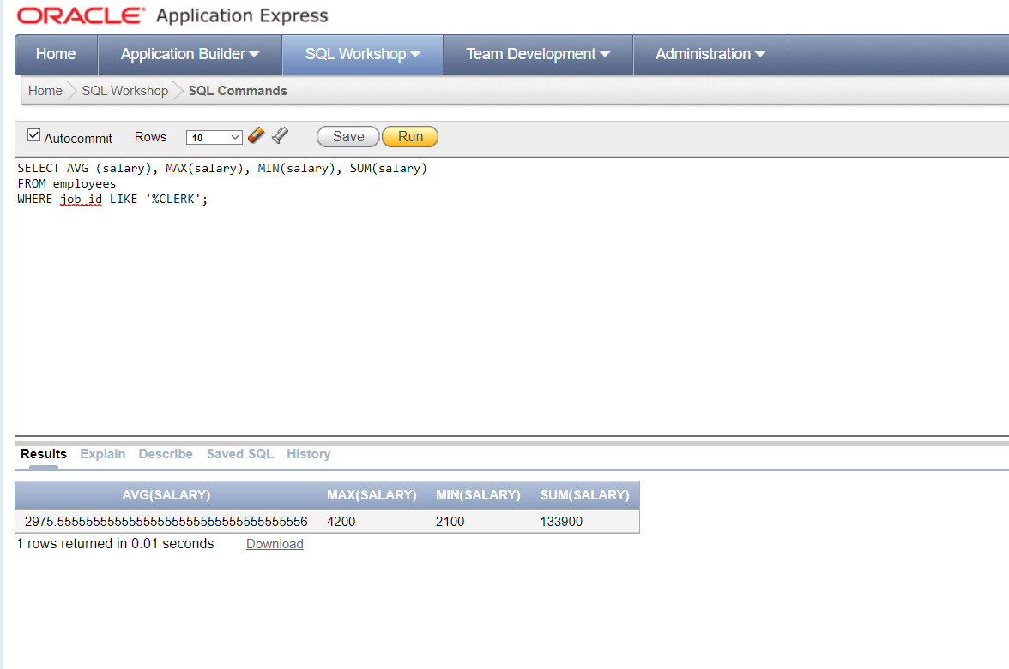

SELECT MIN (hire_date), MAX(hire_date) FROM employees;

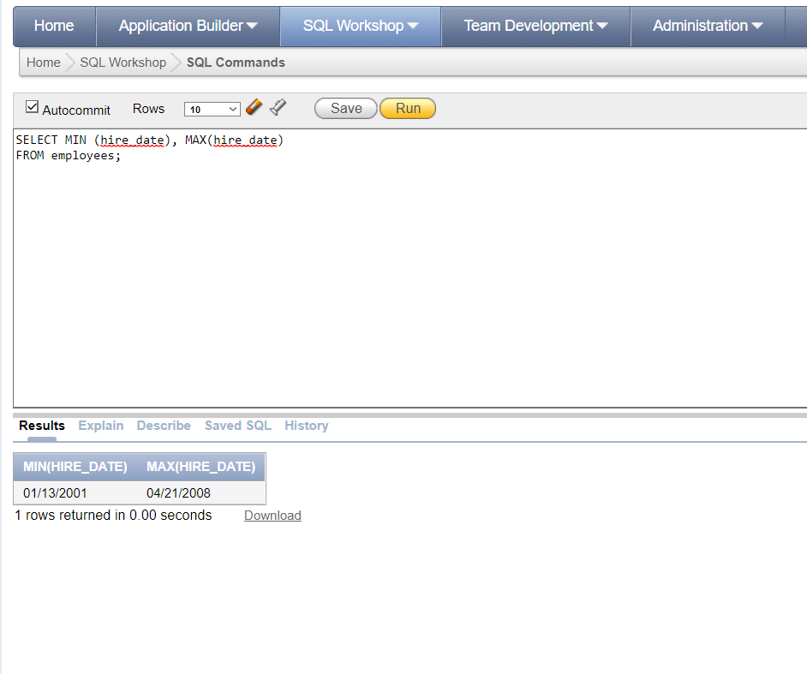

SELECT COUNT(*) FROM employees WHERE department_id=30;

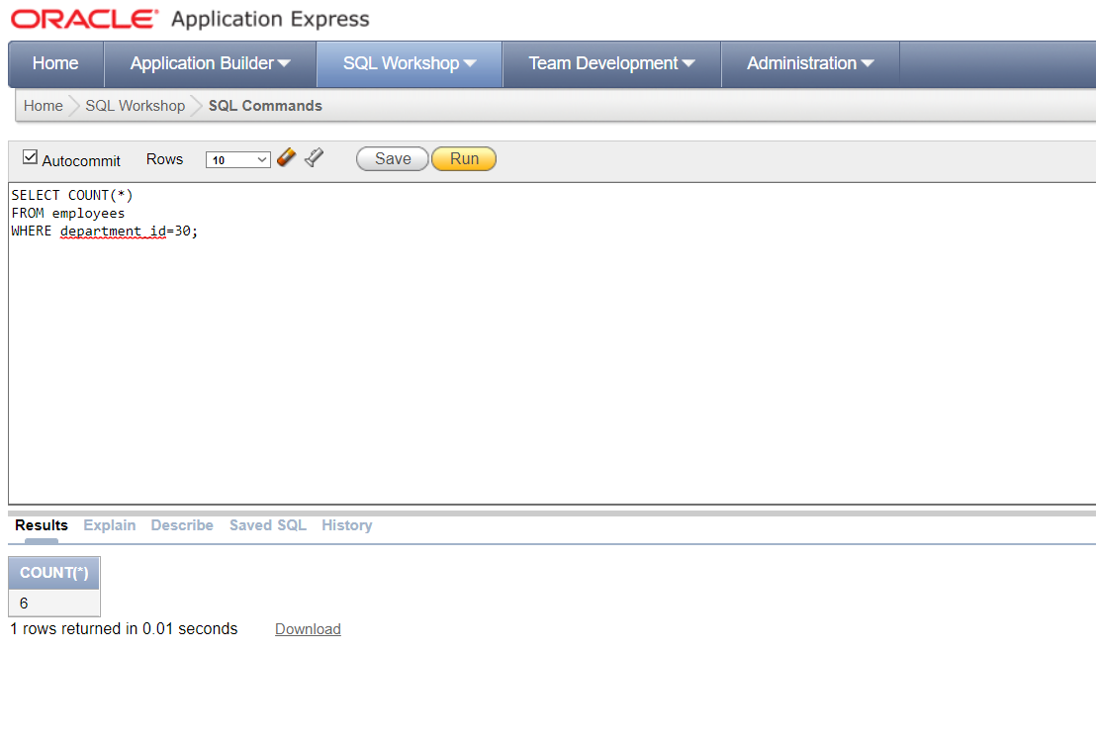

SELECT COUNT(department_id) FROM employees;

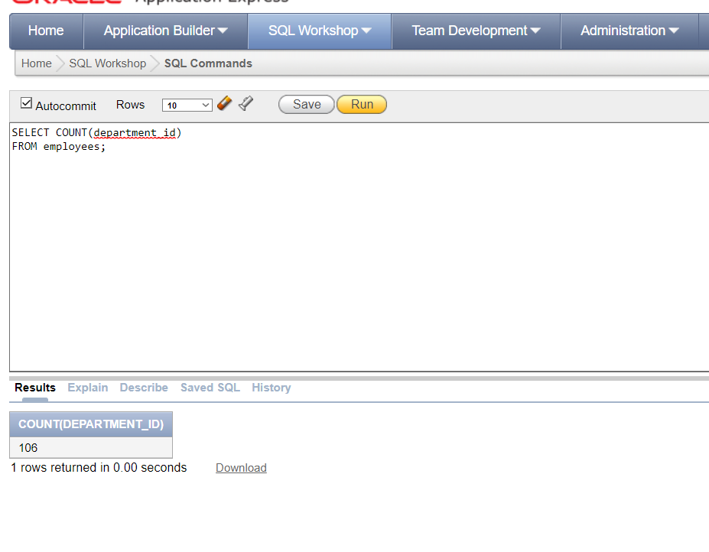

SELECT COUNT (DISTINCT (department_id)) FROM employees;

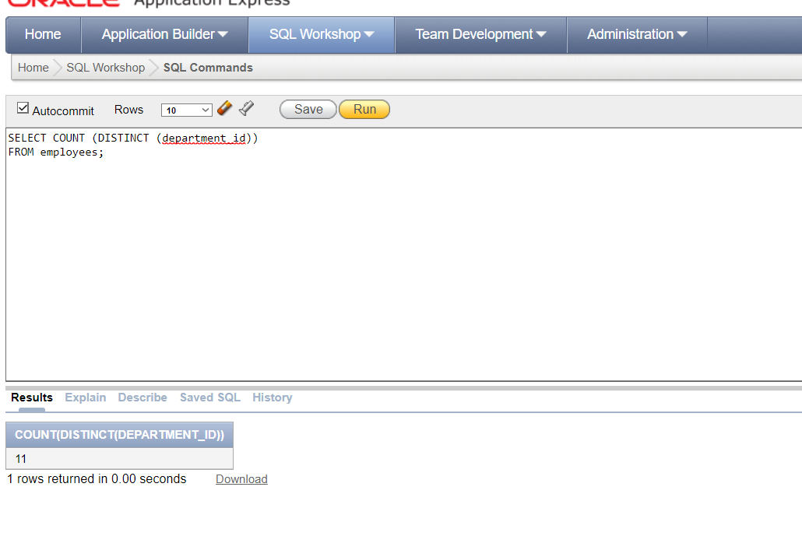

SELECT department_id, AVG(salary) FROM employees GROUP BY department_id;

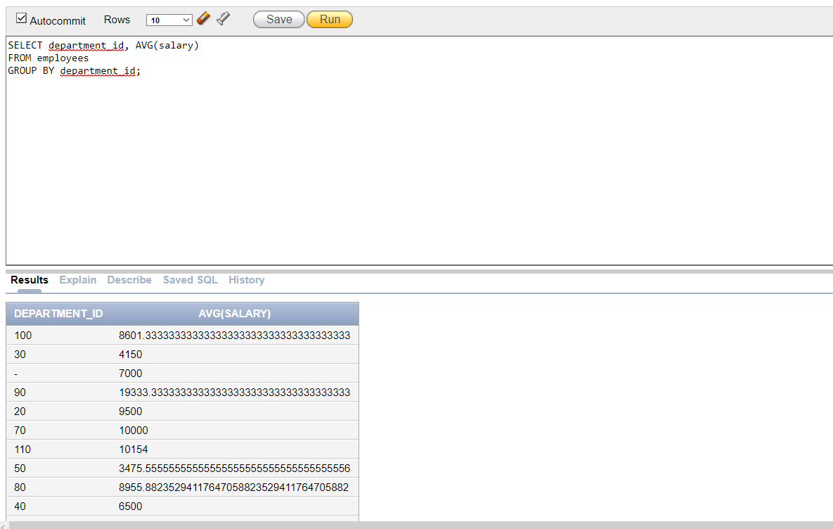

SELECT department_id, job_id, sum (salary) FROM employees GROUP BY department_id, job_id;

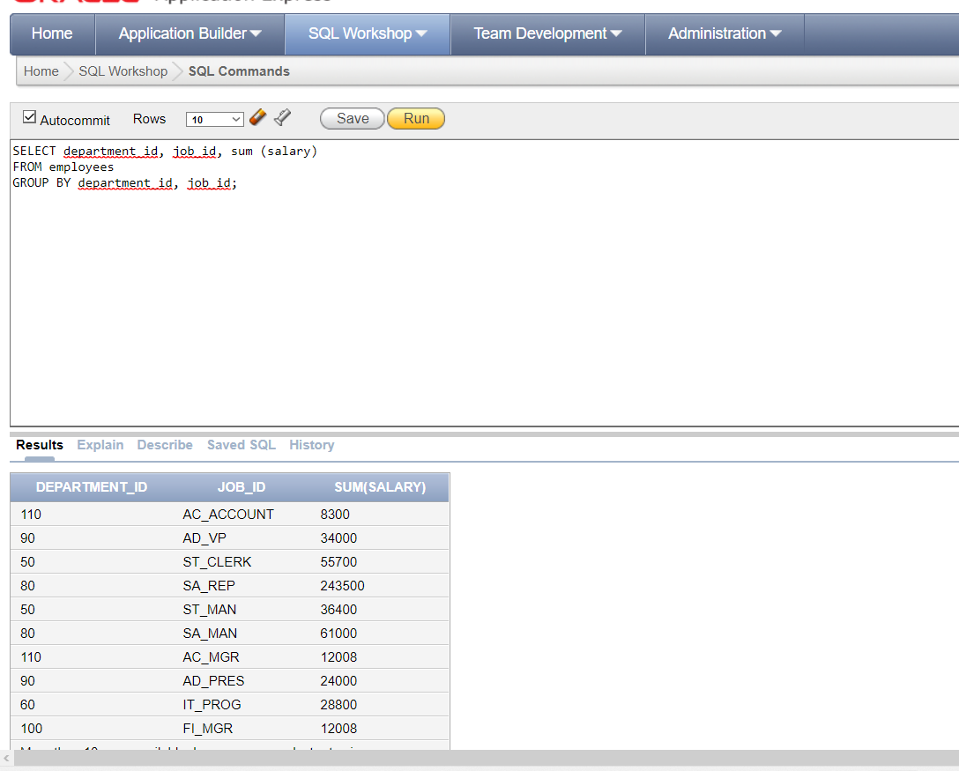

SELECT department_id, max (salary) FROM employees GROUP BY department_id HAVING max (salary)>8000;

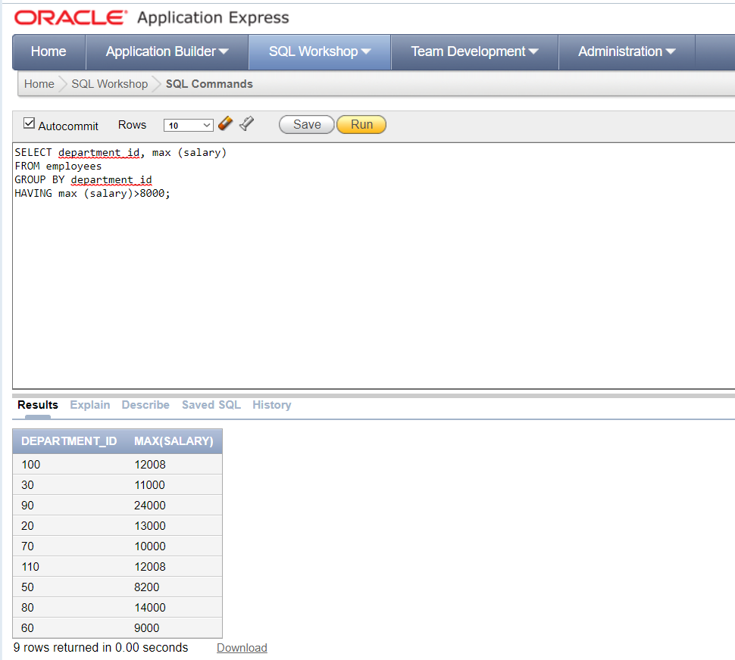

SELECT job_id, SUM (salary) PAYROLL FROM employees WHERE job_id NOT LIKE '% ‘CLERK' GROUP BY job_id HAVING SUM(salary)>5000 ORDER BY SUM(salary);

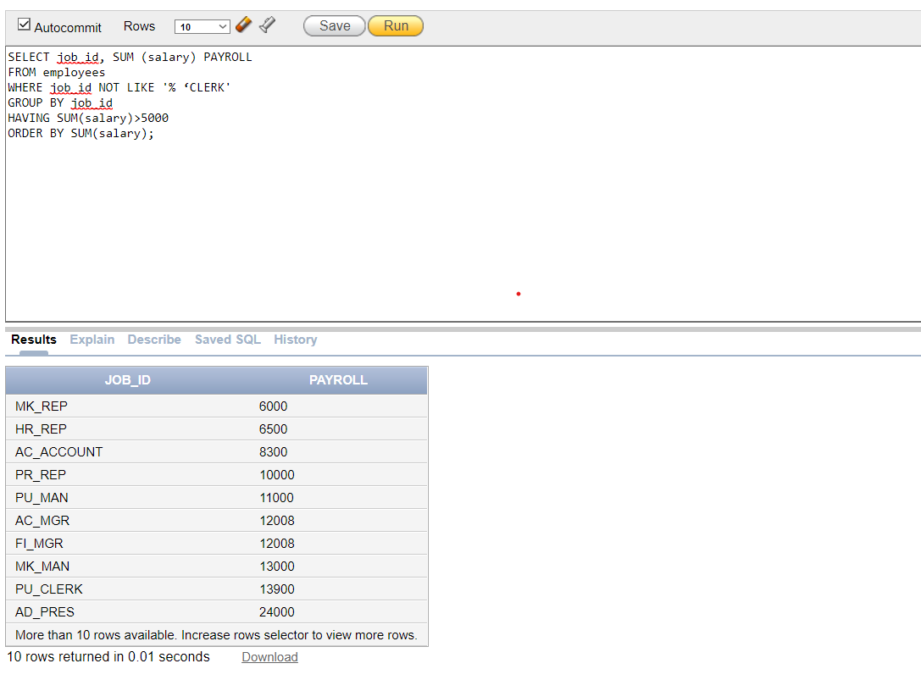

SELECT max(avg (salary)) FROM employees GROUP BY department_id;

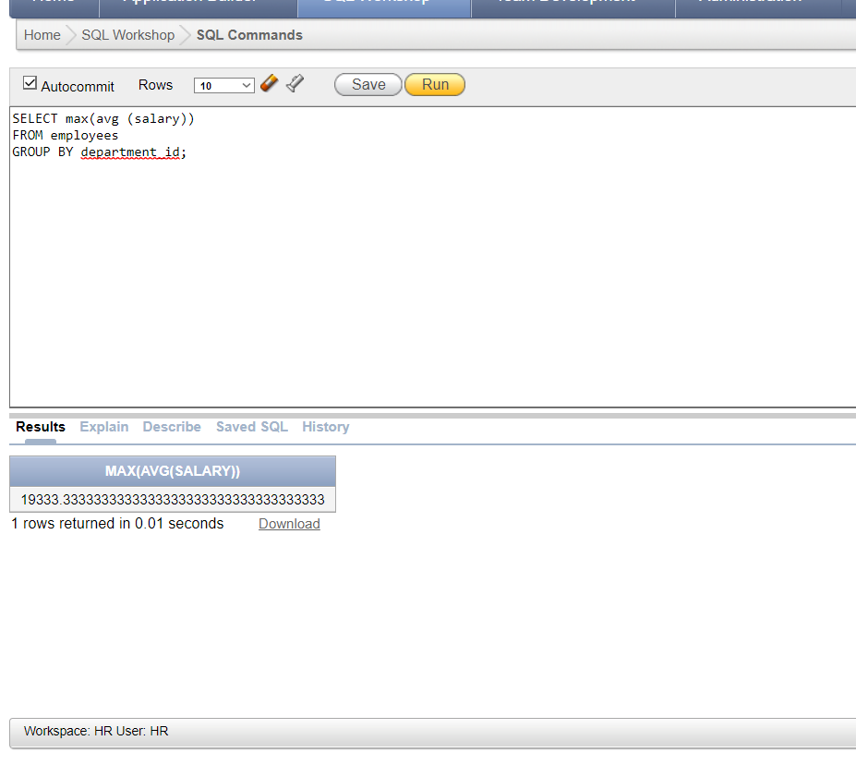

**2. Show the average salary of all those employees whose first_name contains 'a' and 'e'; (3 Marks)**

Select avg(salary) as Average_Salary

From employees

Where first_name like '%a%' and first_name like '%e%';

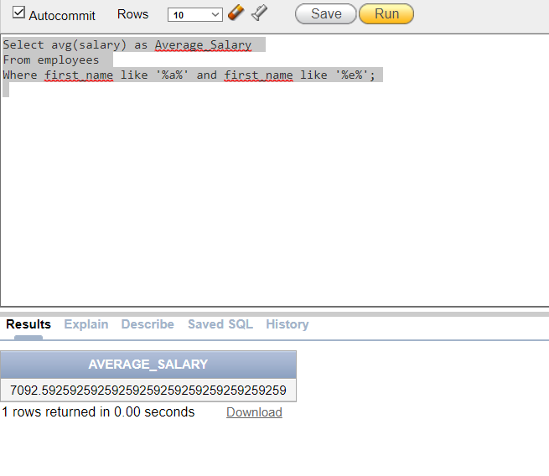

**3. Display the highest, lowest, sum, and average salary of all employees. Label the columns Maximum, Minimum, Sum, and Average, respectively. Round your results up to the two decimal position. (3 Marks)**

Select round(max(salary)) as Maximun,round(min(salary)) as Minimum,round(sum(salary)) as Sum, round(avg(salary)) as Average

From employees;

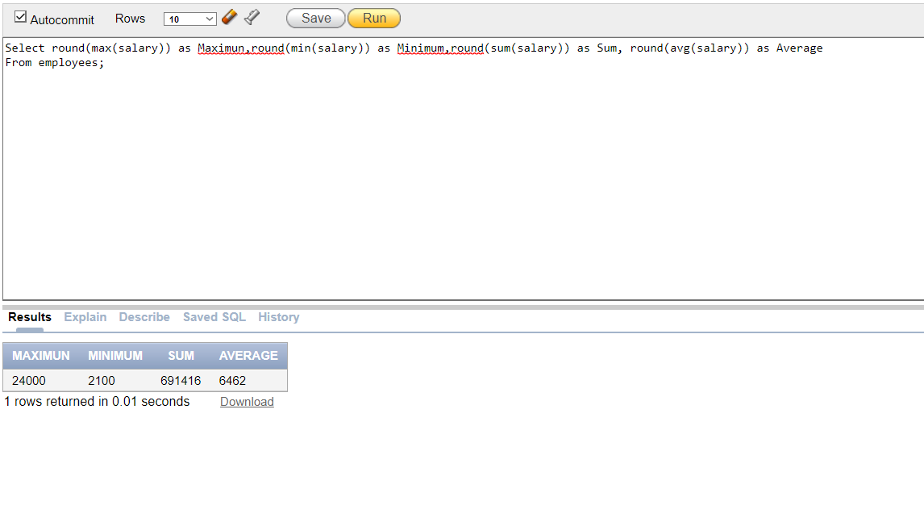

**4. Modify the above questions to display the minimum, maximum, sum,** **and average salary for each job type. ( 3 marks)**

Select round(max(salary)) as Maximun,round(min(salary)) as Minimum,round(sum(salary)) as Sum, round(avg(salary)) as Average,job_id

From employees

Group by job_id;

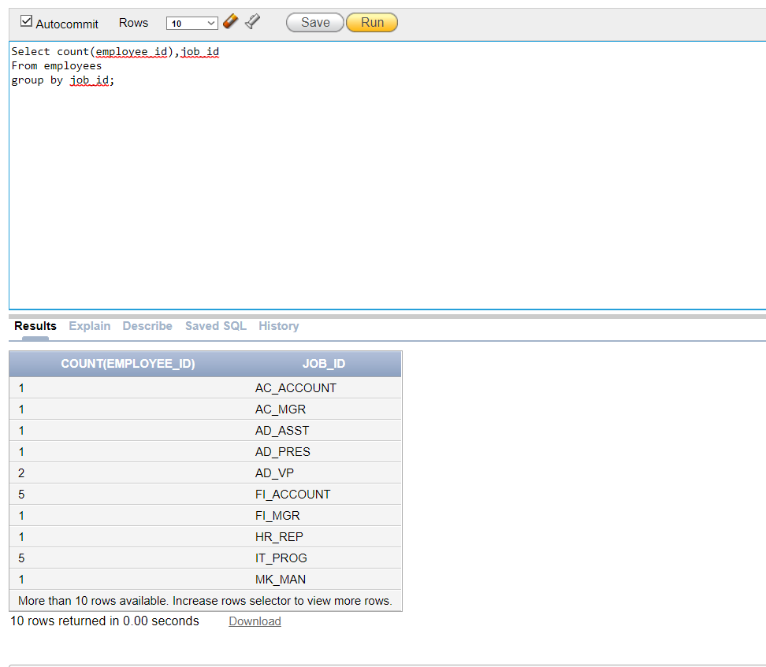

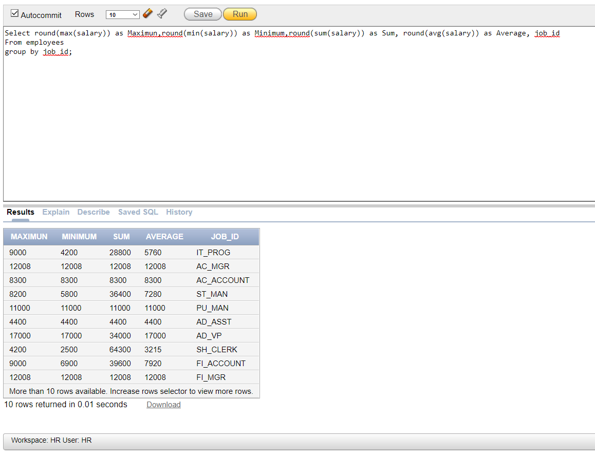

5**. Write a query to display the number of people with the same job. (2 Marks).**